PSYCHOLOGY PROJECT REPORT

Topic: **Cyber security and how its ignorance can lead  
to very dangerous outcomes**

***Group Members:***

|  |
| --- |
| **Muhammad Mussab (22K-4146)** |
| **Muhammad Raza Khan (22K-4355)** |
| **Ilyas Moiz (22K-4255)** |
| **Arafat Khan (22K-4174)** |
| **Daniyal Saeed Dani (22K-4233)** |

***Related Theories***

**Protection Motivation Theory:**

This theory tells that people are motivated to protect themselves from perceived threats. The survey findings align with this theory, as respondents’ level of concern for cyber security reflects their motivation to avoid potential harm.

There may be some discrepancies with the theory as the survey was not just limited to people from the same backgrounds, but it holds true.

**Health Belief Model:**

The Health Belief Model emphasizes that individuals will take preventive action if they believe they are susceptible to a threat and that the benefits of the action outweigh the barriers. The survey results reveal varying levels of susceptibility to cyber threats and a need for greater awareness of the benefits of proactive cyber security measures.

The question about reporting the cyber security incident showed exactly this.

***Survey Results***

***Total Responses: 68***

**Audience:**

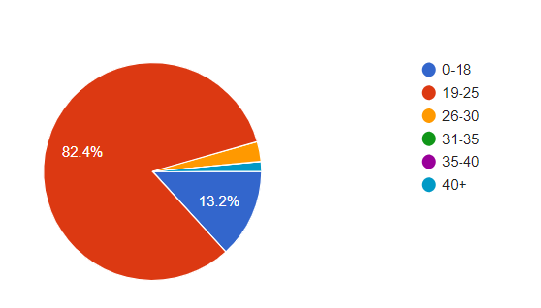

**Gender:**

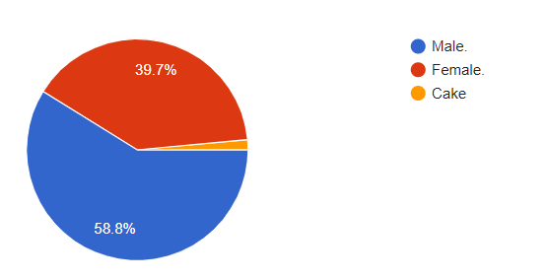

***Findings:***

|  |  |  |  |  |
| --- | --- | --- | --- | --- |
| **How frequently do you update your knowledge about new Cyber Security threats and vulnerabilities?** | **How often do you change your passwords for important online accounts?** | **Have you ever fallen victim to a phishing attack or social engineering scam?** | **Are you cautious about the information you share online, considering Cyber Security risks?** | **What factors would make you more likely to report a Cyber Security incident?** |
| **Do you believe that people around you take Cyber Security seriously?** | **Have you ever lost a device that contained sensitive information?** | **To what extent do Cyber Security concerns contribute to stress or anxiety in your daily life?** | **Have you ever altered your online behavior due to concerns about personal privacy and Cyber threats?** | **In your opinion, how much responsibility do individuals have in maintaining a secure online environment?** |

**Implications and Benefits:**

The survey findings highlight the emotional and mental effects of neglecting cyber security measures, emphasizing anxiety, fear, and a false sense of security. It underlines the need to address both the technical and psychological aspects of cyber security.

**Conclusion:**

The survey illuminates the psychological dimensions of cyber security, emphasizing the need for comprehensive education and awareness programs to empower individuals to take ownership of their online security. By addressing the psychological barriers to proactive cyber security practices, individuals can better protect themselves from the potentially dangerous outcomes of cyber threats.

This survey report provides valuable insights into the psychological aspects of cyber security and offers a foundation for developing effective strategies to promote a culture of cyber security awareness and resilience.